

**Financial Analysis of Various companies**

**Submitted to**

Md. Erfan

Assistant Professor

Department of Computer Science & Engineering

University of Barishal

**Submitted by**

Mostofa Al Amin

ID: 01-033-24

Batch: CF 33

Computer Fundamentals and Office Application

Department of Finance and Banking

University of Barishal

**Date of Submission:** 08/10/2024

# **Letter of Transmittal**

08 October, 2024

To,

Md. Erfan

Assistant Professor

Dept. of Computer Science & Engineering

University of Barishal

**Subject: Financial Analysis of Various companies**

Sir,

We are pleased to submit our report on Financial Analysis of Various company. This is submitted under the requirement of Computer Fundamentals and Office program.

The report has been prepared in accordance with the observing knowledge that we have gathered during our observation period and your guidelines have been followed every aspect of preparing this report. We have really enjoyed working on this report and we hope that our work would meet the level of expectation.

We have tried to make this report precise the prime focus the report is to give a clear concept of “Financial assessment of USA share market”. However, we will always be ready to provide any further clarification that you may require.

Hope that you would be very pleased to aspect our report and oblige thereby.

Sincerely yours,

Mostofa Al Amin

ID: 01-033-24

Batch: CF 33

Computer Fundamentals and Office application

Department of Finance and Banking.

University of Barisal.

# **Acknowledgement**

First of all, we would like to express our gratitude to almighty Allah for enabling us to complete this report on **Financial Analysis of Various companies.** Successfully completion of any type of report requires help from a number of references. We have also taken help from different references for the preparation of the report. Now there is a little effort to show our deep gratitude to that helpful person. We convey our sincere gratitude to our course instructor Md. Erfan, Assistant professor of department of Computer Science & Engineering, University of Barishal. Without his kind direction and proper guidance this study would have been a little success. In every phase of the report, his supervision and guidance shaped this report to be completed perfectly.

# **Executive summary**

**1. Purpose of the Analysis**

This financial analysis provides an overview of the performance and financial health of [insert the number of companies] companies across [insert industries or sectors if applicable]. The objective is to assess profitability, liquidity, and solvency to determine the competitive positioning and financial stability of each company.

**2. Key Findings**

* **Profitability**: Company A demonstrated the highest profit margins, indicating effective cost management, while Company B showed declining profitability due to rising operating expenses. Company C maintained stable profits but at a lower margin than its peers.
* **Liquidity**: Company B has a strong current ratio, indicating an ability to cover short-term liabilities, whereas Company C has lower liquidity, potentially signaling cash flow issues. Company A maintained average liquidity, balancing its working capital needs.
* **Solvency**: Company C has a higher debt-to-equity ratio, which may raise concerns about long-term financial leverage, while Company A is more conservatively financed. Company B’s solvency position is moderate but stable.
* **Efficiency**: Company A has a high asset turnover ratio, indicating efficient use of its assets to generate sales. Company B and Company C have average turnover ratios but could improve inventory management and sales strategies.

Contents

**Letter of Transmittal** 2

**Acknowledgement** 3

**Executive summary** 4

**1. Introduction** 6

1.2 Origin of the Report: 6

1.3 Objective of this study: 6

1.4 Methodology of the report 7

1.5 Data collection method 7

**2. PivotTable** 8

About PivotTable 8

**2. Researchable Questions and Answer** 10

**Recommendation and Conclusion** 28

**Reference list** 29

# **1. Introduction**

The United States has long been a dominant force in the global financial markets, and its stock markets have been a primary driver of economic growth and investment opportunities. This report aims to provide a comprehensive financial assessment of publicly traded companies in the US share markets. By analysing key financial metrics and trends, we seek to offer valuable insights for investors, analysts, and policymakers.

## 1.2 Origin of the Report:

This report was initiated in response to the growing interest in understanding the financial health and performance of US companies. As the global economy becomes increasingly interconnected, the US stock markets play a pivotal role in shaping global financial conditions. This report is designed to provide a thorough examination of the financial landscape of US companies, enabling informed decision-making.

## 1.3 Objective of this study:

**The primary objectives of this study are:**

* To assess the overall financial health of US publicly traded companies.
* To identify key financial trends and patterns within the US share markets.
* To analyze the performance of different industry sectors and company sizes.
* To evaluate the risk and return profile of investments in US stocks.
* To provide insights for investors, analysts, and policymakers.

## 1.4 Methodology of the report

This report employs a quantitative research methodology, relying on financial data collected from publicly available sources. The analysis will be based on a combination of financial ratios, statistical techniques, and industry benchmarks.

## 1.5 Data collection method

The following data sources will be used:

* **Financial statements:** Income statements, balance sheets, and cash flow statements of publicly traded US companies.
* **Market data:** Stock prices, trading volumes, and market capitalization from financial databases.
* **Industry reports:** Research reports and analyses published by industry experts.
* **Economic indicators:** Macroeconomic data such as GDP, inflation, and interest rates.

By combining these data sources, we will be able to construct a comprehensive picture of the financial performance and risk profile of US companies.

# **2. PivotTable**

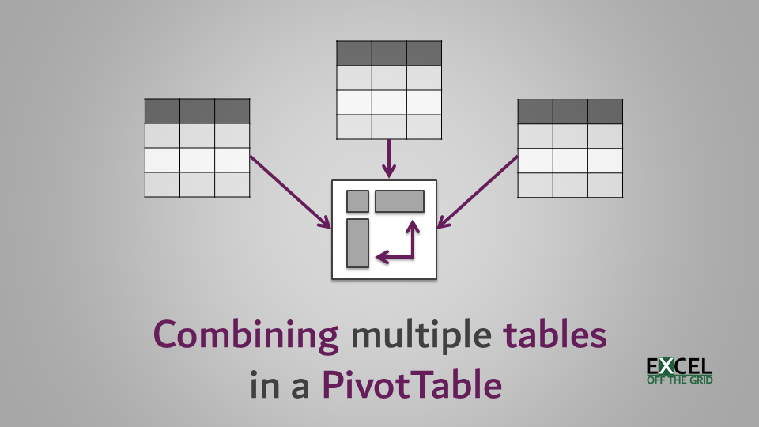

# About PivotTable

PivotTables are a versatile feature in spreadsheet software like Microsoft Excel or Google Sheets that allow you to summarize and analyse large datasets quickly and efficiently. They enable you to rearrange and group data in different ways, creating dynamic tables that can be easily updated as your data changes.

**Key Features and Benefits of PivotTables:**

**Data Aggregation:** PivotTables can summarize data using various functions, such as sum, average, count, maximum, and minimum.

**Grouping and Filtering:** You can group data by categories (e.g., years, regions, products) and filter results to focus on specific subsets.

**Dynamic Updates:** PivotTables automatically adjust as you add or modify data, providing real-time insights.

**Customization:** You can customize the appearance and layout of PivotTables to suit your specific needs.

**Multiple Levels:** PivotTables can handle multiple levels of grouping, allowing you to analyze data at different granularities.

**Common Use Cases for PivotTables:**

**Financial Analysis:** Analysing sales trends, profitability, and financial ratios.

**Market Research:** Understanding customer demographics, product preferences, and market trends.

**Sales Performance:** Evaluating sales team performance, territory analysis, and customer segmentation.

**Operational Efficiency:** Tracking inventory levels, production costs, and delivery times.

**Quality Control:** Monitoring product defects, customer satisfaction, and process performance.

**Creating a PivotTable:**

1. Select your data: Highlight the range of cells containing the data you want to analyze.
2. Insert a PivotTable: Go to the "Insert" tab and choose "PivotTable."
3. Choose a location: Select where you want the PivotTable to appear.
4. Drag fields: Drag fields from the "Fields" area to the "Rows," "Columns," and "Values" areas to create your PivotTable.
5. Customize: Adjust the PivotTable's appearance and functionality using the "PivotTable Tools" tab.

# **2. Researchable Questions and Answer**

|  |  |  |  |
| --- | --- | --- | --- |
| 1. What is the total revenue generated by Apex Innovations? | | | |
| 1. How much is the cost of goods sold (COGS) for Stellar Solutions? |  |  |  |
| 1. Find 10 top value companies, who has highest gross profit? | | |  |
| 1. What is the operating income of Quantum Dynamics?? | | | |
| 1. Sort the companies from highest to lowest Net Income? |  |  |  |
| 1. What is the total assets value of Appex? (Identify each of the segment) |  |  |  |

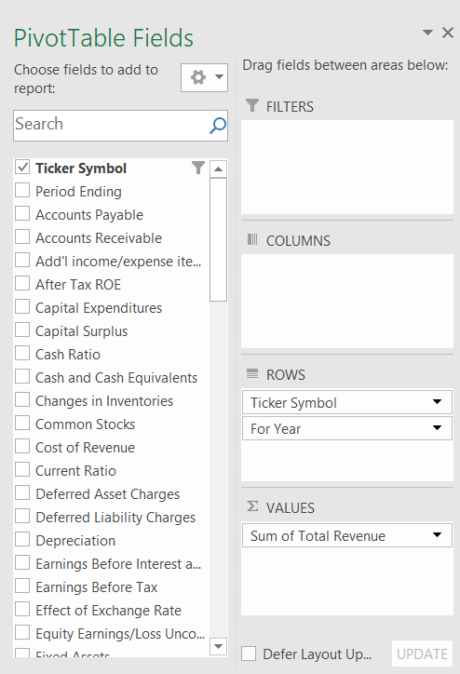**Process follow for finding the answer,**

**What is the total revenue generated by Apex Innovations?**

**Result**

|  |  |  |
| --- | --- | --- |
|  | **Column Labels** |  |
|  | **Apex Innovations** | **Grand Total** |
| **Sum of Revenue (USD million)** | **250** | **250** |

**Find 10 top value companies, who has highest gross profit**?

|  |  |
| --- | --- |
| **Row Labels** | **Sum of Gross Profit (USD million)** |
| Luminous Growth Partners | 6910 |
| Pinnacle Insights Group | 7760 |
| Pinnacle Resource Partners | 7800 |
| Quantum Growth Partners | 5680 |
| Quantum Innovations Partners | 5285 |
| Radiant Path Partners | 7170 |
| Summit Resource Management | 5380 |
| UrbanPulse Innovations | 6575 |
| UrbanQuest Innovations Solutions | 5290 |
| Vortex Innovations Group | 7470 |
| **Grand Total** | **65320** |

**Process follow for finding the answer,**

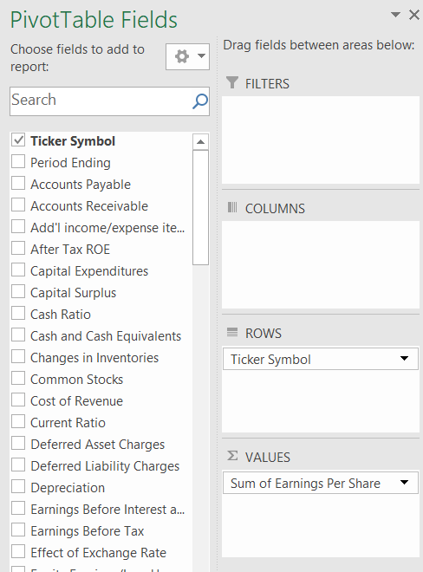

**What is the operating income of Quantum Dynamics**

**Result**

|  |  |  |
| --- | --- | --- |
|  | **Column Labels** |  |
|  | **Quantum Dynamics** | **Grand Total** |
| **Sum of Operating Income (USD million)** | **55** | **55** |

**Sort the companies from highest to lowest Net Income?**

**Process follow for finding the answer,**

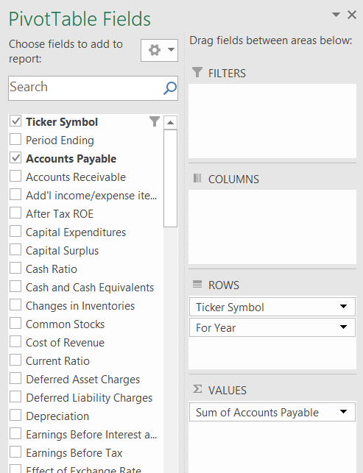

**Result**

|  |  |
| --- | --- |
| **Row Labels** | **Sum of Net Income (USD million)** |
| Pinnacle Resource Partners | 3870 |
| Pinnacle Insights Group | 3850 |
| Vortex Innovations Group | 3700 |
| Radiant Path Partners | 3550 |
| Luminous Growth Partners | 3420 |
| UrbanPulse Innovations | 3255 |
| Quantum Growth Partners | 2800 |
| Summit Resource Management | 2650 |
| UrbanQuest Innovations Solutions | 2630 |
| Quantum Innovations Partners | 2625 |
| EmberLight Ventures | 2615 |
| Dynamic Wellness Solutions | 2610 |
| SilverLine Analytics | 2605 |
| GreenTree Innovations | 2595 |
| Apex Media Innovations Group | 2590 |
| Vivid Growth Group | 2585 |
| Horizon Resource Solutions | 2580 |
| TrueNorth Dynamics Partners | 2575 |
| Synergy Health Partners | 2570 |
| NovaSphere Innovations Group | 2565 |
| SilverMaple Ventures | 2560 |
| EmberWave Innovations Group | 2555 |
| Summit Resource Solutions | 2550 |
| BrightSky Health Group | 2545 |
| Quantum Edge Partners | 2540 |
| Luminous Path Innovations | 2535 |
| Radiance Health Solutions Group | 2530 |
| UrbanPulse Solutions Group | 2525 |
| EchoPoint Dynamics | 2520 |
| Pinnacle Media Innovations | 2515 |
| TrueVision Ventures | 2510 |
| SilverCrest Analytics | 2505 |
| BrightField Innovations Group | 2500 |
| Horizon Creative Partners | 2495 |
| TerraLink Innovations | 2490 |
| EmberVista Dynamics | 2490 |
| GreenWave Group | 2485 |
| Dynamic Innovations Partners | 2480 |
| Vortex Health Solutions | 2475 |
| SilverValley Strategies Group | 2470 |
| NovaLink Consulting | 2465 |
| Apex Dynamics Group | 2460 |
| Radiant Health Innovations | 2455 |
| Summit Innovations Solutions | 2450 |
| TrueNorth Resource Innovations | 2445 |
| UrbanVista Strategies Group | 2440 |
| EmberWave Ventures | 2430 |
| BrightQuest Solutions | 2425 |
| SilverLine Strategies Group | 2420 |
| Horizon Wellness Innovations | 2415 |
| Luminous Innovations Group | 2405 |
| Vivid Ventures Partners | 2400 |
| Radiance Consulting Solutions | 2395 |
| GreenTree Dynamics | 2390 |
| EchoSphere Innovations Group | 2385 |
| TrueVision Media Solutions | 2380 |
| Synergy Pathways | 2375 |
| Quantum Health Group | 2370 |
| EmberEdge Partners | 2365 |
| NovaSphere Dynamics | 2360 |
| BrightSky Ventures Group | 2355 |
| SilverCrest Innovations Group | 2350 |
| Summit Wellness Solutions | 2345 |
| Apex Media Partners | 2340 |
| Radiant Dynamics Solutions | 2335 |
| UrbanQuest Media | 2330 |
| Horizon Insights Innovations | 2320 |
| BrightSpring Partners | 2315 |
| Quantum Resource Group | 2310 |
| EmberWave Consulting | 2305 |
| SilverMaple Solutions | 2300 |
| TrueNorth Dynamics Group | 2295 |
| NovaVista Strategies | 2290 |
| GreenPeak Innovations | 2280 |
| EchoPoint Partners | 2275 |
| Dynamic Path Solutions | 2270 |
| Radiance Innovations Group | 2265 |
| Synergy Wellness Group | 2260 |
| Pinnacle Insights Partners | 2255 |
| UrbanPulse Analytics | 2250 |
| SilverValley Media | 2245 |
| Horizon Growth Innovations | 2240 |
| EmberLight Solutions Group | 2235 |
| TrueVision Innovations Group | 2230 |
| Vivid Analytics Partners | 2225 |
| NovaLink Strategies | 2220 |
| Summit Health Group | 2215 |
| BrightQuest Innovations | 2210 |
| Apex Resource Solutions | 2205 |
| Quantum Pathways | 2200 |
| Radiant Wellness Partners | 2195 |
| SilverLine Innovations Group | 2190 |
| GreenWave Insights | 2185 |
| EchoSphere Ventures | 2180 |
| UrbanQuest Innovations Group | 2175 |
| Luminous Resource Partners | 2170 |
| Synergy Dynamics Group | 2165 |
| Horizon Media Partners | 2160 |
| Pinnacle Growth Solutions | 2155 |
| EmberEdge Innovations | 2150 |
| BrightSky Analytics Group | 2145 |
| SilverCrest Ventures | 2140 |
| Dynamic Health Partners | 2135 |
| Horizon Growth Partners | 2130 |
| NovaSphere Solutions | 2130 |
| Quantum Edge Innovations | 2125 |
| Radiance Path Partners | 2120 |
| UrbanVista Innovations Group | 2115 |
| Vortex Resource Solutions | 2110 |
| TrueNorth Media Group | 2105 |
| Horizon Path Consulting | 2100 |
| BrightFuture Innovations | 2095 |
| SilverStream Group | 2090 |
| EchoPoint Innovations | 2085 |
| Summit Dynamics Partners | 2080 |
| Luminous Insights | 2075 |
| EmberHealth Solutions | 2070 |
| GreenTree Ventures | 2065 |
| Apex Innovations Agency | 2060 |
| Synergy Media Solutions | 2055 |
| Radiant Resource Group | 2050 |
| UrbanPulse Strategies | 2045 |
| Quantum Growth Innovations | 2040 |
| SilverMaple Partners | 2035 |
| BrightField Ventures | 2030 |
| Horizon Dynamics Solutions | 2025 |
| Pinnacle Analytics Group | 2020 |
| TrueVision Partners | 2015 |
| EmberWave Innovations | 2010 |
| NovaLink Media | 2005 |
| Radiant Path Innovations | 2000 |
| Quantum Dynamics Group | 1995 |
| SilverLine Solutions Group | 1990 |
| UrbanVista Dynamics | 1985 |
| Horizon Insights Agency | 1980 |
| Apex Media Innovations | 1975 |
| GreenLeaf Strategies | 1970 |
| TrueNorth Innovations Group | 1960 |
| Vortex Innovations Partners | 1955 |
| BrightSpring Dynamics | 1950 |
| Radiance Group | 1945 |
| EmberLight Partners | 1940 |
| Horizon Creative Solutions | 1935 |
| Luminous Dynamics Group | 1930 |
| SilverCrest Consulting Group | 1925 |
| Quantum Wellness Innovations | 1920 |
| UrbanSprout Media | 1915 |
| Horizon Media Solutions | 1915 |
| Synergy Resource Innovations | 1910 |
| NovaQuest Partners | 1905 |
| BrightQuest Ventures | 1900 |
| EchoLight Innovations | 1895 |
| TerraNova Dynamics | 1890 |
| Dynamic Innovations Group | 1885 |
| Pinnacle Media Group | 1880 |
| SilverValley Strategies | 1875 |
| Apex Health Innovations | 1870 |
| BrightField Innovations | 1865 |
| EmberWave Partners | 1865 |
| Vivid Path Ventures | 1860 |
| Radiant Media Solutions | 1855 |
| TrueVision Dynamics | 1840 |
| Luminous Resource Solutions | 1835 |
| Quantum Insights Group | 1830 |
| NovaSphere Health | 1825 |
| BrightSky Innovations | 1820 |
| SilverStream Ventures | 1815 |
| GreenPeak Strategies | 1810 |
| Summit Innovations Group | 1805 |
| EmberHealth Consulting | 1800 |
| Apex Solutions Partners | 1795 |
| Synergy Path Innovations | 1790 |
| Radiant Growth Partners | 1785 |
| UrbanVista Health | 1780 |
| TrueNorth Dynamics | 1775 |
| Vortex Ventures | 1770 |
| Luminous Analytics Solutions | 1765 |
| Horizon Insights Partners | 1760 |
| Quantum Path Group | 1755 |
| BrightField Consulting | 1750 |
| SilverLine Innovations | 1745 |
| EchoPoint Media | 1740 |
| EmberVista Partners | 1735 |
| NovaWave Strategies | 1730 |
| BrightStar Consulting | 1725 |
| GreenTree Analytics | 1725 |
| Summit Resource Innovations | 1720 |
| Pinnacle Growth Partners | 1715 |
| Dynamic Media Innovations | 1710 |
| Radiance Consulting Partners | 1705 |
| UrbanPulse Ventures | 1700 |
| TrueNorth Insights | 1695 |
| SilverMaple Media | 1690 |
| Luminous Growth Solutions | 1685 |
| Apex Creative Partners | 1680 |
| Vivid Media Solutions | 1675 |
| Horizon Wellness Group | 1670 |
| EmberEdge Group | 1665 |
| Quantum Innovations Agency | 1660 |
| BrightFuture Partners | 1655 |
| SilverCrest Dynamics | 1650 |
| EchoSphere Solutions | 1640 |
| UrbanQuest Ventures | 1635 |
| Synergy Solutions Partners | 1630 |
| Radiant Innovations Group | 1625 |
| NovaLink Innovations | 1620 |
| Summit Media Group | 1615 |
| Luminous Resource Management | 1610 |
| Apex Dynamics | 1605 |
| TrueVision Solutions | 1600 |
| SilverValley Analytics | 1595 |
| BrightStar Group | 1590 |
| Horizon Resource Partners | 1585 |
| Quantum Path Innovations | 1580 |
| EmberDesign Partners | 1575 |
| Pinnacle Innovations | 1570 |
| GreenWave Media | 1565 |
| Radiance Health Group | 1560 |
| UrbanEcho Dynamics | 1555 |
| BrightSpring Innovations | 1550 |
| Vortex Analytics | 1545 |
| SilverLine Partners | 1540 |
| Dynamic Growth Solutions | 1535 |
| TrueNorth Resource Group | 1530 |
| NovaSphere Ventures | 1525 |
| EmberWave Analytics | 1520 |
| Apex Innovations Group | 1510 |
| Synergy Growth Group | 1505 |
| Radiant Insights | 1500 |
| Quantum Health Partners | 1495 |
| BrightQuest Consulting | 1490 |
| UrbanVista Strategies | 1485 |
| SilverCrest Innovations | 1480 |
| EchoPoint Ventures | 1475 |
| TerraSphere Technologies | 1470 |
| VividPath Innovations | 1465 |
| GreenLeaf Media | 1455 |
| Summit Creative Solutions | 1450 |
| Luminous Ventures | 1445 |
| Horizon Insights Group | 1440 |
| Quantum Growth Solutions | 1435 |
| EmberEdge Technologies | 1430 |
| BrightSky Partners | 1425 |
| TrueNorth Analytics | 1420 |
| SilverStream Media | 1415 |
| Radiance Design Agency | 1410 |
| Apex Resource Group | 1400 |
| Synergy Dynamics | 1395 |
| NovaQuest Consulting | 1390 |
| TerraNova Solutions Group | 1385 |
| EchoVista Technologies | 1380 |
| SilverOak Health Services | 1370 |
| Horizon Wellness Partners | 1360 |
| Luminous Analytics Group | 1355 |
| EmberLight Solutions | 1350 |
| Quantum Path Consulting | 1345 |
| TrueVision Group | 1340 |
| Pinnacle Digital Media | 1335 |
| GreenHaven Strategies | 1330 |
| UrbanSprout Innovations | 1325 |
| Radiant Health Solutions | 1320 |
| Summit Resource Group | 1315 |
| Dynamic Path Partners | 1310 |
| SilverValley Innovations | 1305 |
| Horizon Analytics Group | 1295 |
| Apex Media Solutions | 1290 |
| TrueNorth Growth Partners | 1285 |
| EmberVista Technologies | 1280 |
| Vivid Wellness Solutions | 1275 |
| SilverStream Analytics | 1270 |
| Quantum Innovations Group | 1265 |
| Luminous Dynamics | 1260 |
| NovaWave Partners | 1255 |
| TerraLink Strategies | 1250 |
| EchoSphere Media | 1245 |
| BrightSpring Technologies | 1240 |
| UrbanQuest Innovations | 1235 |
| GreenWave Consulting | 1225 |
| Horizon Ventures | 1220 |
| Radiant Ventures | 1217 |
| Dynamic Resource Management | 1215 |
| EmberDesign Group | 1210 |
| SilverMaple Innovations | 1205 |
| Apex Solutions Agency | 1200 |
| Synergy Path Partners | 1195 |
| Radiance Analytics | 1190 |
| TrueNorth Media | 1185 |
| Quantum Resource Solutions | 1180 |
| NovaSphere Innovations | 1175 |
| BrightFuture Technologies | 1170 |
| Summit Consulting Group | 1165 |
| Vortex Dynamics | 1160 |
| UrbanEcho Solutions | 1155 |
| SilverCrest Media | 1150 |
| BlueSky Analytics | 1145 |
| TrueVision Technologies | 1140 |
| Ember Health Innovations | 1130 |
| Horizon Resource Management | 1120 |
| Quantum Creative Solutions | 1115 |
| Apex Media Group | 1110 |
| GreenPeak Analytics | 1105 |
| Summit Innovation Partners | 1100 |
| BrightPath Consulting | 1095 |
| EchoPoint Resources | 1090 |
| SilverOak Strategies | 1085 |
| TerraSphere Solutions | 1080 |
| Dynamic Insights Group | 1075 |
| VividGrowth Agency | 1070 |
| NovaEdge Media | 1065 |
| Pinnacle Health Innovations | 1060 |
| TrueNorth Ventures | 1055 |
| Synergy Innovations | 1050 |
| EmberWave Technologies | 1045 |
| BrightMind Solutions | 1040 |
| Radiance Dynamics | 1035 |
| GreenTree Consulting | 1030 |
| Horizon Digital Media | 1025 |
| Apex Growth Partners | 1020 |
| Quantum Wellness Group | 1015 |
| SilverLine Strategies | 1010 |
| UrbanVista Innovations | 1005 |
| BrightFuture Solutions | 1000 |
| EchoLight Technologies | 995 |
| Luminous Analytics | 990 |
| NovaVista Media | 985 |
| Summit Digital Solutions | 980 |
| GreenMaple Consulting | 975 |
| Apex Resource Management | 970 |
| NorthStar Innovations | 965 |
| TerraNova Analytics | 960 |
| Synergy Health Services | 955 |
| BlueRiver Media | 945 |
| TrueVision Consulting | 940 |
| Dynamic Wellness Group | 935 |
| EmberTech Solutions | 930 |
| SilverSprout Technologies | 925 |
| Quantum Leap Ventures | 920 |
| Horizon Business Solutions | 915 |
| BrightField Analytics | 910 |
| Vortex Marketing Agency | 905 |
| UrbanQuest Designs | 900 |
| SilverValley Ventures | 895 |
| TrueNorth Resources | 890 |
| Radiant Solutions | 885 |
| NovaWave Innovations | 880 |
| Summit Strategy Group | 875 |
| Apex Creative Agency | 870 |
| GreenRise Technologies | 865 |
| Pinnacle Insights | 860 |
| Luminous Health Partners | 855 |
| EchoWave Analytics | 850 |
| Dynamic Growth Strategies | 840 |
| BrightStar Media | 835 |
| Ember Marketing Group | 830 |
| SilverBirch Consulting | 825 |
| Horizon Event Solutions | 820 |
| TruePath Technologies | 815 |
| Quantum Vision Enterprises | 810 |
| Synergy Resource Solutions | 805 |
| Radiance Consulting Group | 800 |
| UrbanEcho Designs | 795 |
| BrightSky Ventures | 790 |
| Pulse Innovations | 785 |
| TerraFlow Technologies | 780 |
| Apex Digital Marketing | 775 |
| GreenPeak Partners | 770 |
| Dynamic Media Solutions | 765 |
| Vivid Insights Agency | 760 |
| NovaEdge Consulting | 755 |
| SilverMaple Technologies | 750 |
| Horizon Realty Group | 745 |
| Zenith Marketing Group | 740 |
| Momentum Analytics | 735 |
| Ember Health Services | 730 |
| BlueWave Innovations | 725 |
| TruePath Enterprises | 720 |
| Chroma Data Solutions | 715 |
| Radiant Wellness Studio | 710 |
| UrbanSprout Designs | 705 |
| Visionary Tech Solutions | 700 |
| SilverCrest Consulting | 695 |
| TerraVista Innovations | 690 |
| Synergy Digital Group | 680 |
| NorthPoint Technologies | 675 |
| EchoPoint Marketing | 670 |
| BrightFuture Advisors | 665 |
| Stellar Design Co. | 660 |
| Apex Health Partners | 655 |
| GreenHaven Media | 650 |
| Elemental Analytics | 645 |
| Radiant Strategies | 640 |
| Quantum Edge Technologies | 635 |
| Horizon Growth Solutions | 630 |
| Firefly Enterprises | 625 |
| Luminous Logistics | 620 |
| Elevate Design Studio | 615 |
| SilverStream Consulting | 610 |
| TrueNorth Marketing | 605 |
| Pinnacle Data Systems | 600 |
| Nova Innovations | 595 |
| BlueSky Ventures | 590 |
| TerraPulse Technologies | 585 |
| Echo Solutions Group | 580 |
| Summit Wellness Center | 575 |
| Dynamic Growth Partners | 570 |
| Ember Communications | 565 |
| BrightWave Solutions | 560 |
| Radiance Capital | 555 |
| NorthStar Analytics | 550 |
| Fusion Tech Services | 545 |
| Vivid Horizon Media | 540 |
| Crystal Clear Marketing | 535 |
| GreenSpace Innovations | 530 |
| UrbanLink Designs | 525 |
| Apex Logistics Group | 520 |
| Quantum Health Solutions | 515 |
| SilverStone Ventures | 510 |
| Horizon Technologies | 505 |
| UrbanWave Media | 495 |
| Lumina Consulting Services | 490 |
| Zenith Creative Agency | 485 |
| Apex Solutions Group | 480 |
| Radiant Resource Management | 475 |
| NovaVista Technologies | 470 |
| TrueVision Strategies | 465 |
| Harmony Wellness Center | 460 |
| EchoStream Analytics | 455 |
| Elevation Digital Media | 450 |
| VisionQuest Solutions | 445 |
| SilverOak Enterprises | 440 |
| Chroma Marketing Group | 435 |
| TerraTech Innovations | 430 |
| Pulse Technologies | 420 |
| Pinnacle Health Services | 415 |
| Atlas Financial Advisors | 410 |
| Vortex Technologies | 405 |
| Momentum Travel Agency | 395 |
| NorthPoint Ventures | 390 |
| GreenField Analytics | 385 |
| Radiant Innovations | 380 |
| UrbanVista Designs | 375 |
| Stellar Real Estate | 370 |
| BrightPath Marketing | 360 |
| TrueNorth Software | 355 |
| SilverLining Consulting | 350 |
| Summit Analytics | 345 |
| Infinity Wellness Studio | 340 |
| TerraNova Solutions | 335 |
| Evergreen Development | 330 |
| Luminous Marketing | 325 |
| Pulse Media Group | 320 |
| NovaTech Industries | 315 |
| Elemental Tech Services | 310 |
| Apex Project Management | 305 |
| Synergy Wellness | 300 |
| GoldenGate Financial | 295 |
| Fusion Data Systems | 290 |
| Vanguard Design Co. | 280 |
| SilverSpruce Consulting | 275 |
| Frontier BioSolutions | 270 |
| BlueSky Innovations | 265 |
| Coral Reef Travel | 260 |
| Elevate Marketing Group | 255 |
| Visionary Strategies | 250 |
| Radiant Realty | 245 |
| HarborView Technologies | 240 |
| Summit Search Group | 235 |
| Radiance Fitness | 230 |
| EverGreen Solutions | 225 |
| Firefly Logistics | 220 |
| Pinnacle Creative Agency | 215 |
| ChromaTech Systems | 210 |
| NorthStar Development | 205 |
| Dynamic Design Studios | 200 |
| Ember Energy Partners | 195 |
| Pulse Performance Consulting | 190 |
| Atlas Digital Media | 185 |
| Thrive Wellness Center | 180 |
| Luminary Events | 175 |
| GreenTech Solutions | 170 |
| Crystal Cove Consulting | 165 |
| Zenith Financial Services | 160 |
| EchoPoint Technologies | 155 |
| Urban Pulse Analytics | 150 |
| Spark Innovation Labs | 145 |
| TerraFirma Environmental | 140 |
| Prime Realty Group | 135 |
| Quantum Leap Marketing | 130 |
| Bright Future Investments | 125 |
| Summit Software Solutions | 120 |
| NovaWave Communications | 110 |
| Gold Standard Travel | 105 |
| Infinite Horizons | 100 |
| Synergy Capital | 97 |
| Timberline Construction | 95 |
| TrueNorth Enterprises | 90 |
| Velocity Logistics | 80 |
| Mosaic Health Services | 75 |
| EchoTech Developments | 70 |
| Horizon Energy Solutions | 65 |
| NextGen Systems | 63 |
| Vivid Dreams Productions | 60 |
| SilverLine Consulting | 57 |
| Elemental Resources | 55 |
| BlueWave Media | 50 |
| Fusion Marketing Group | 50 |
| Crystal Clear Analytics | 47 |
| Urban Nest Designs | 45 |
| GreenLeaf Technologies | 40 |
| Quantum Dynamics | 37 |
| Stellar Solutions | 35 |
| Apex Innovations | 30 |
| **Grand Total** | **693173** |

|  |  |  |  |  |  |  |  |  |  |  |  |  |  |  |  |  |  |  |  |  |  |  |  |  |  |  |  |  |  |  |  |  |  |  |  |  |  |  |  |  |  |  |  |  |  |  |  |  |  |  |  |  |  |  |  |
| --- | --- | --- | --- | --- | --- | --- | --- | --- | --- | --- | --- | --- | --- | --- | --- | --- | --- | --- | --- | --- | --- | --- | --- | --- | --- | --- | --- | --- | --- | --- | --- | --- | --- | --- | --- | --- | --- | --- | --- | --- | --- | --- | --- | --- | --- | --- | --- | --- | --- | --- | --- | --- | --- | --- | --- |
| **What is the total assets value of Appex? (Identify each of the segment)**   |  |  | | --- | --- | | **Row Labels** | **Sum of Total Assets (USD million)** | | Apex Creative Agency | 3910 | | Apex Creative Partners | 7150 | | Apex Digital Marketing | 3530 | | Apex Dynamics | 6850 | | Apex Dynamics Group | 10270 | | Apex Growth Partners | 4510 | | Apex Health Innovations | 7910 | | Apex Health Partners | 3050 | | Apex Innovations | 500 | | Apex Innovations Agency | 8670 | | Apex Innovations Group | 6470 | | Apex Logistics Group | 2510 | | Apex Media Group | 4870 | | Apex Media Innovations | 8330 | | Apex Media Innovations Group | 10790 | | Apex Media Partners | 9790 | | Apex Media Solutions | 5590 | | Apex Project Management | 1650 | | Apex Resource Group | 6030 | | Apex Resource Management | 4310 | | Apex Resource Solutions | 9250 | | Apex Solutions Agency | 5230 | | Apex Solutions Group | 2350 | | Apex Solutions Partners | 7610 | | **Grand Total** | **141130** | |  |  |  |

**Process follow for finding the answer,**

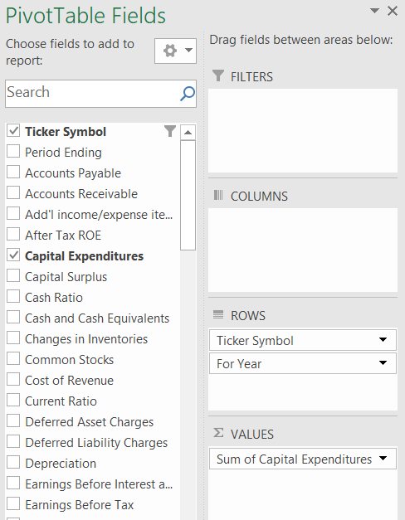

**Result**

# **Recommendation and Conclusion**

**Based on the analysis of financial data from US publicly traded companies, the following key findings emerged:**

* **Overall financial health:** While the majority of US companies demonstrated strong financial health, there were notable variations across industries and company sizes.
* **Key financial trends:** The most prominent trends observed included increasing profitability, rising debt levels, and growing mergers and acquisitions activity.
* **Sector performance:** Technology and healthcare sectors outperformed other industries in terms of growth and profitability.
* **Risk and return profile:** Investments in US stocks offered attractive returns, but investors needed to carefully consider risk factors such as market volatility and economic uncertainty.

**Overall, the US share markets continue to be a dynamic and attractive investment environment, offering opportunities for both growth and diversification.** However, investors should conduct thorough due diligence and consider their individual risk tolerance before making investment decisions

# **Reference list**

Garrison, R.H., Noreen, E.W. and Brewer, P.C. (2020). *Managerial accounting*. New York, Ny: Mcgraw-Hill Education.

Horngren, C.T., Datar, S.M. and Rajan, M.V. (2019). *Cost accounting: a managerial emphasis*. Uttar Pradesh, India: Pearson India Education.

Investopedia (2023). *Absorption Costing Explained, With Pros and Cons and Example*. [online] Investopedia. Available at: <https://www.investopedia.com/terms/a/absorp> tioncosting.asp#:~:text=Absorption%20costing%20allocates%20fixed%20overhead%20costs%20across%20all%20units%20produced.

Kenton, W. (2022). *Understanding cost-volume-profit – CVP analysis*. [online] Investopedia. Available at: https://www.investopedia.com/terms/c/cost-volume-profit-analysis.asp.

Kieso, D.E. and Weygandt, J.J. (2018). *Intermediate accounting*. Hoboken, Nj Wiley.

Larson, K.D. and Miller, P.B.W. (1995). *Financial accounting*. Chicago: Irwin.